Fluid shear stress-induced exosomes from liver cancer cells promote activation of cancer-associated fibroblasts via IGF2-PI3K axis

Tang Feng¹, Fei Fang¹, Chunhe Zhang¹, Tiantian Li¹, Jia He¹, Yang Shen¹, Hongchi Yu^{1,}*, Xiaoheng Liu^{1,}*

¹Institute of Biomedical Engineering, West China School of Basic Medical Sciences & Forensic Medicine, Sichuan University, 610041 Chengdu, Sichuan, China

*Correspondence: liuxiaohg@scu.edu.cn (Xiaoheng Liu); yuhongchi@scu.edu.cn (Hongchi Yu)

The supplementary materials are listed as below:
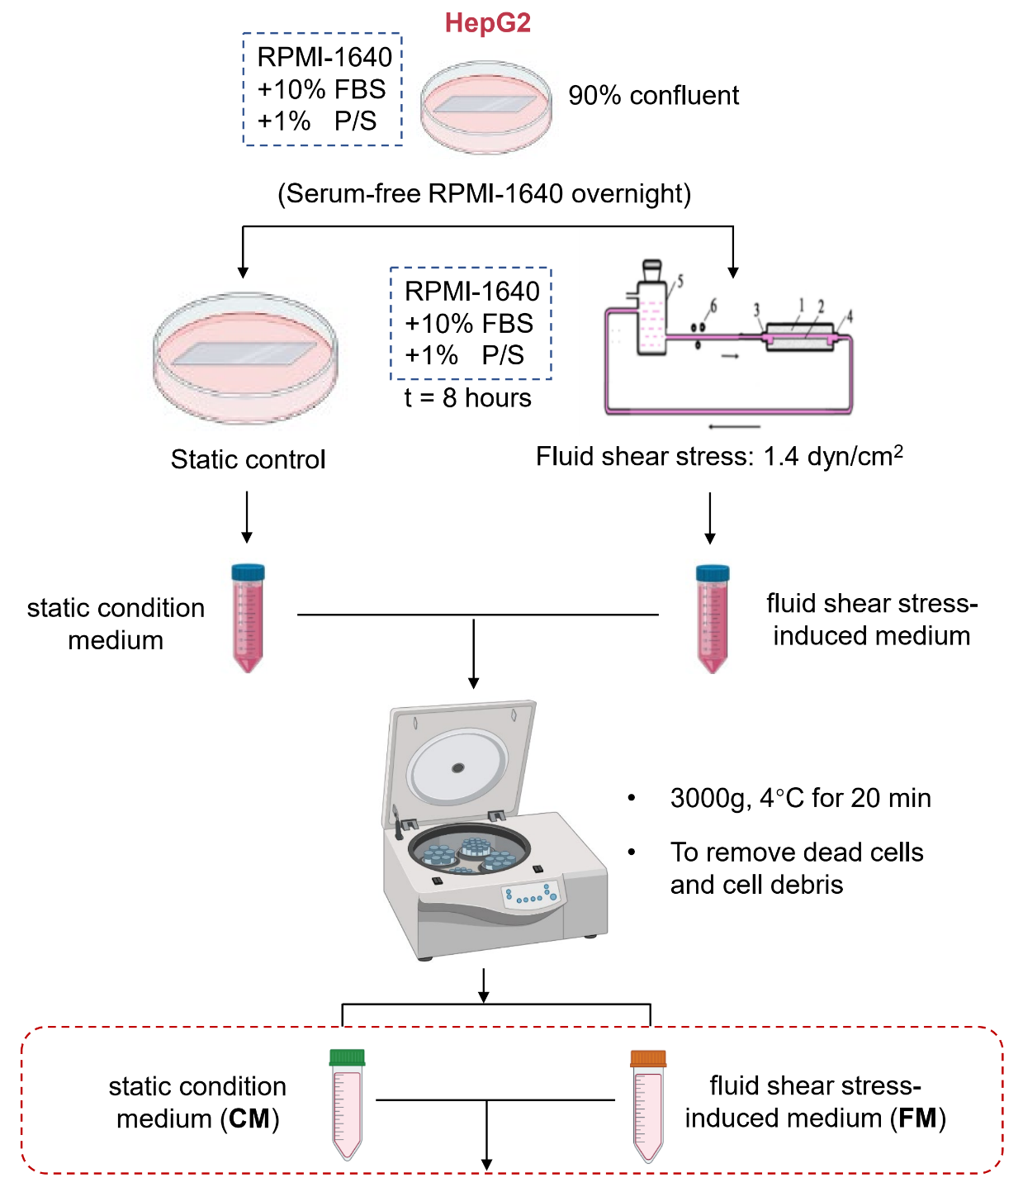

Supplementary Fig. 1. The collection process of different condition mediums was used in this study.

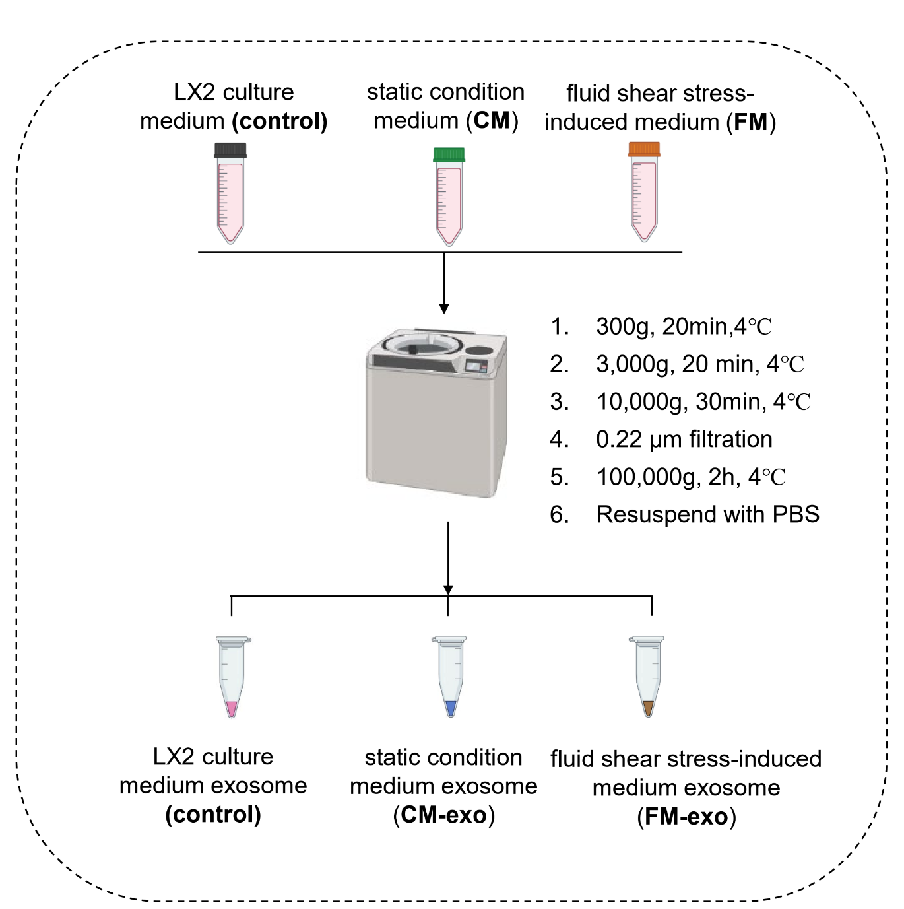
Supplementary Fig. 2. The isolation process of exosomes from different mediums.

Supplemental Table 1. Primary Antibody and Reagent information.
Antibody information |  |  |  | Dilution/amount
Antibody | Company | Catalog Number | Description | Western Blot | IF
anti-GAPDH | Signalway Antibody | #21612 | Rabbit polyclonal | 1:5000
anti-FAP | HuaAn Biotechnology | ER1706-84 | Rabbit polyclonal | 1:1000 | 1:100
anti-α-SMA | Abcam | Ab32575 | Rabbit monoclonal | 1:2000
anti-CD63 | HuaAn Biotechnology | ET1607-2 | Rabbit monoclonal | 1:1000
anti-Alix | Cell Signaling Technology | #2171 | Mouse monoclonal | 1:1000
anti-Hsp70 | HuaAn Biotechnology | ET1601-11 | Rabbit monoclonal | 1:1000
anti-IGF2 | Abcam | Ab177467 | Rabbit monoclonal | 1:1000
anti-PI3K | Cell Signaling Technology | #4292 | Rabbit monoclonal | 1:1000
anti-p-PI3K | Cell Signaling Technology | #17366 | Rabbit monoclonal | 1:1000
anti-AKT | Cell Signaling Technology | #9272 | Rabbit polyclonal | 1:1000
anti- p-AKT | Cell Signaling Technology | #4060 | Rabbit monoclonal | 1:1000
Reagent information |  |  |  | Concentration
Reagent | Company | Country | Catalog Number
IGF2 | Peprotech | USA | 100-12 | 0.5 ug/mL
Xentuzumab | Wuhan Chemstan Biotechnology | China | CSD00418 | 1 ug/mL

